
Foundation University Islamabad
School of Science and Technology

Name: Hunaina Yasir Roll Number: 073
Subject: PF Lab Section: B
LAB # 9
Tasks
9.1 Write a C++ program to enter and display student attendance records of 5 days using the array.
Source code:
#include <iostream>
using namespace std;

int main()
{
int attendance[5];

cout << "Enter attendance for 5 days:";
for (int i = 0; i < 5; i++)
{
cin >> attendance[i];
}
cout << "\nAttendance records:" << endl;

for (int i = 0; i < 5; i++)
{
cout << "Day " << i + 1 << ": " << attendance[i] << endl;
}

return 0;
}

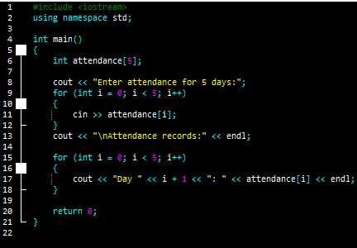
Output:
Enter attendance for 5 days:23
43
54
12
4

Attendance records:
Day 1: 23
Day 2: 43
Day 3: 54
Day 4: 12
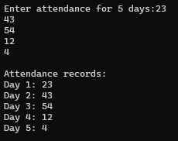
Day 5: 4

9.2 Write a C++ program that declares two 3 x 3int arrays (Matrices). Store random values using nested for loops in the array and perform Addition and Multiplication of Matrices, stores the result of the operation in another Matrix (output arrays). And displays the results.
Source code:
#include <iostream>
#include <cstdlib>
using namespace std;

int main()
{
int A[3][3], B[3][3], add[3][3], mul[3][3];

for (int i = 0; i < 3; i++)
{
for (int j = 0; j < 3; j++)
{
A[i][j] = rand() % 10;
B[i][j] = rand() % 10;
}
}

for (int i = 0; i < 3; i++)
{
for (int j = 0; j < 3; j++)
{
add[i][j] = A[i][j] + B[i][j];
}
}

for (int i = 0; i < 3; i++)
{
for (int j = 0; j < 3; j++)
{
mul[i][j] = 0;
for (int k = 0; k < 3; k++)
{
mul[i][j] = mul[i][j] + A[i][k] * B[k][j];
}
}
}

cout << "Matrix A" << endl;
for (int i = 0; i < 3; i++)
{
for (int j = 0; j < 3; j++)
{
cout << A[i][j] << " ";
}
cout << endl;
}

cout << "Matrix B" << endl;
for (int i = 0; i < 3; i++)
{
for (int j = 0; j < 3; j++)
{
cout << B[i][j] << " ";
}
cout << endl;
}

cout << "Addition Result" << endl;
for (int i = 0; i < 3; i++)
{
for (int j = 0; j < 3; j++)
{
cout << add[i][j] << " ";
}
cout << endl;
}

cout << "Multiplication Result" << endl;
for (int i = 0; i < 3; i++)
{
for (int j = 0; j < 3; j++)
{
cout << mul[i][j] << " ";
}
cout << endl;
}

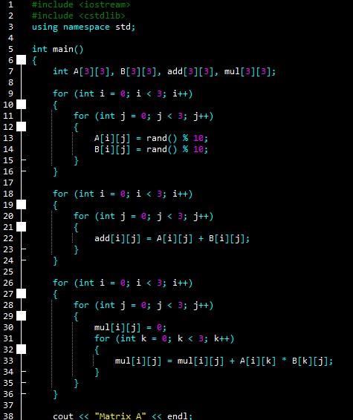
return 0;
}
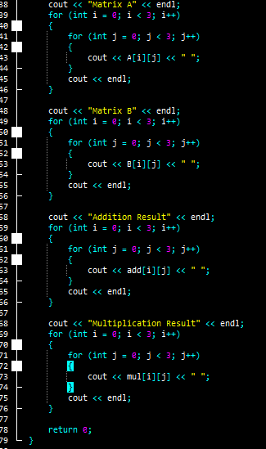
Output:
Matrix A
1 4 9
8 2 5
1 1 5
Matrix B
7 0 4
8 4 5
7 1 2
Addition Result
8 4 13
16 6 10
8 2 7
Multiplication Result
102 25 42
107 13 52
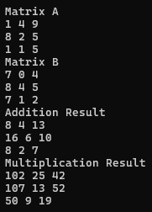
50 9 19

9.3 Write a C++ program, which:
- Populates a two-dimensional array of size 10 x 10 with random numbers between 0 and 9 (Hint: C++ has a built-in function for random number generation)
- Prompts the user to enter a number.
- Searches for this number in the 10 x 10 array and
- Displays the location where the number is found in the array.
Your program should display ‘Value not found’ if the user’s specified number is not found in the 10 x 10 array. Your program should have the following interface.

Source code:
Enter a value to find in the 10 x 10 array: 5
Found at location [0][5]
Found at location [1][9]
Found at location [4][6]
Found at location [7][0]
4 instances were found.
The 10 x 10 array is:
8964657812
4631128745
6783423231
2321406784
0194765323
2121343786
6781213241
5121113476
7876443123
4321478301

#include <iostream>
#include <cstdlib>
using namespace std;

int main() {
cout << "Hunaina Yasir" << endl;
cout << "Roll Number: 073" << endl << endl;

int arr[10][10];
int value;
int count = 0;

for (int i = 0; i < 10; i++) {
for (int j = 0; j < 10; j++) {
arr[i][j] = rand() % 10;
}
}

cout << "Enter a value to find in the 10 x 10 array: ";
cin >> value;

for (int i = 0; i < 10; i++) {
for (int j = 0; j < 10; j++) {
if (arr[i][j] == value) {
cout << "Found at location [" << i << "][" << j << "]" << endl;
count++;
}
}
}

if (count == 0) {
cout << "Value not found" << endl;
} else {
cout << count << " instances were found." << endl;
}

cout << "The 10 x 10 array is:" << endl;
for (int i = 0; i < 10; i++) {
for (int j = 0; j < 10; j++) {
cout << arr[i][j];
}
cout << endl;
}

return 0;
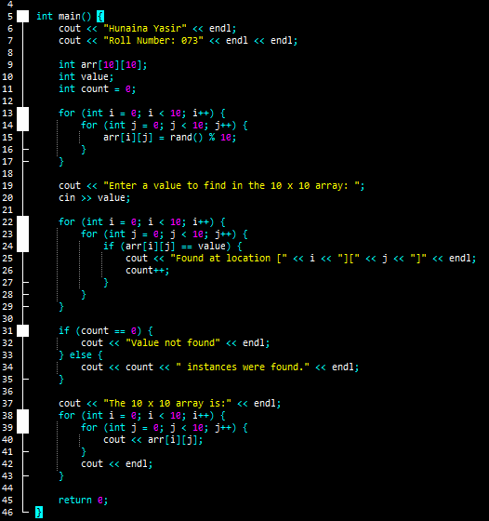
}

Output:
Hunaina Yasir
Roll Number: 073

Enter a value to find in the 10 x 10 array: 5
Found at location [1][0]
Found at location [1][1]
Found at location [1][6]
Found at location [2][9]
Found at location [3][8]
Found at location [6][1]
Found at location [7][1]
7 instances were found.
The 10 x 10 array is:
1740948824
5517115276
1423221685
7618927954
3123341138
7427793198
6502860248
6509006138
9344606618
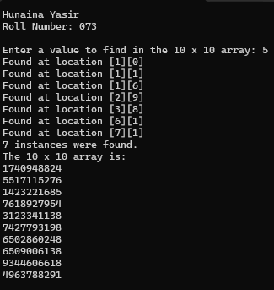
4963788291

9.4 Understand, Explain and show the output of the following code.
- #include <iostream>
- #include <stdlib.h> /* srand, rand */
- #include<string.h>
- using namespace std;
- int main(){
- //integer Arrays sorting
- //array declaration
- int arr[10];
- int i,j;
- int temp;
- //read n elements
- for(i=0;i<10;i++)
- {
- //cout<<"Enter element at index ["<<i<<"] ";
- arr[i]=rand() % 100;
- //cin>>arr[i];
- }
- //print input elements
- cout<<"Unsorted Array elements:"<<endl;
- for(i=0;i<10;i++)
- cout<<arr[i]<<"\t";
- cout<<endl;
- //sorting - ASCENDING ORDER
- for(i=0;i<10;i++){
- for(j=i+1;j<10;j++){
- if(arr[i]>arr[j]){ //12,50,33
- temp =arr[i]; //50
- arr[i]=arr[j]; //12
- arr[j]=temp; //50
- }
- }
- }
- //print sorted array elements
- cout<<"Sorted (Ascending Order) Array elements:"<<endl;
- for(i=0;i<10;i++)
- cout<<arr[i]<<"\t";
- cout<<endl;
- //String Arrays
- string st_name[3] = {"Bilal","Zubair","Ali"};
- string stemp;
- //sorting - ASCENDING ORDER
- cout<<"\n\nUnSorted (Ascending Order) Array elements:"<<endl;
- for(i=0;i<3;i++)
- cout<<st_name[i]<<"\t";
- for(i=0;i<3;i++){
- for(j=i+1;j<3;j++){
- if(st_name[i]>st_name[j]){
- stemp =st_name[i];
- st_name[i]=st_name[j];
- st_name[j]=stemp;
- }
- }
- }
- cout<<"\nSorted (Ascending Order) Array elements:"<<endl;
- for(i=0;i<3;i++)
- cout<<st_name[i]<<"\t";
- //CHAR ARRAYS
- //strcpy( destination, source ); copy from destinition to source
- //strcmp (str1, str2 );Compares str1 to str2
- //Returns an integral value indicating the relationship between the strings:
- //return value indicates
- // <0 it will return less than 0 if first char of str1 is greater than first char of str2
- // 0 the contents of both strings are equal
- // >0 it will return greater than 0 if first char of value 1 is less than first char of valu 2
- char chst_name [3][20];
- char t[20]; //temp variariable
- cout<<"\n\n";
- for(i=0;i<3;i++){
- cout<<"Enter Value in char array ";
- cin>>chst_name[i];
- }
- cout<<"\n\n";
- cout<<"UNSorted (Ascending Order) Array elements:"<<endl;
- for(i=0;i<3;i++)
- cout<<chst_name[i]<<"\t";
- cout<<endl;
- //sorting algo
- for(i=0; i<3; i++){
- for(j=0; j<3; j++){
- if(strcmp(chst_name[i], chst_name[j])<0) //it will return less than 0 if first char of value 1 is greater than first char of valu 2
- {
- strcpy(t, chst_name[i]); //strcpy( destination, source )
- strcpy(chst_name[i], chst_name[j]);
- strcpy(chst_name[j], t);
- }
- }
- }
- //print sorted array elements in char array
- cout<<"Sorted (Ascending Order) Array elements:"<<endl; for(i=0;i<3;i++)
- cout<<chst_name[i]<<"\t";
- cout<<endl;
- return 0;
- }

Answer:
This program shows how to arrange things in order. First, it puts 10 random numbers in an array, shows them as they are, then arranges them from smallest to biggest and shows them again. After that, it takes three names stored as strings, shows them in their original order, then arranges them alphabetically (A to Z) and prints them. Finally, it asks the user to enter three names using character arrays, shows them before sorting, then arranges them alphabetically and prints the sorted result. In short, the program teaches how to sort numbers and names in ascending order using simple loops.

Output:

Hunaina Yasir
Roll number: 073
Unsorted Array elements:
41 67 34 0 69 24 78 58 62 64
Sorted (Ascending Order) Array elements:
0 24 34 41 58 62 64 67 69 78

UnSorted (Ascending Order) Array elements:
Bilal Zubair Ali
Sorted (Ascending Order) Array elements:
Ali Bilal Zubair

Enter Value in char array a
Enter Value in char array s
Enter Value in char array d

UNSorted (Ascending Order) Array elements:
a s d
Sorted (Ascending Order) Array elements:
a d s
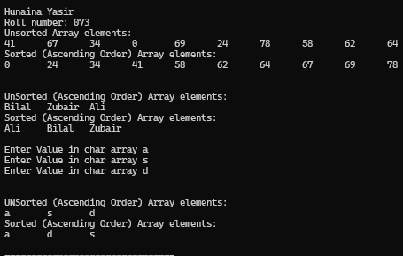

9.5 Write down the output of the following code.
- #include <iostream>
- using namespace std;
- int main(){
- int a[10][10], trans[10][10], r, c, i, j;
- cout<<"Enter rows and columns of matrix: ";
- cin>>r>>c;
- cout<<endl<<"Enter elements of matrix: "<<endl;
- for(i = 0; i < r; ++i){
- for(j = 0; j < c; ++j){
- cout << "Enter elements a" << i + 1 << j + 1 << ": ";
- cin >> a[i][j];
- }
- }
- cout << endl << "Entered Matrix: " << endl;
- for(i = 0; i < r; ++i){
- for(j = 0; j < c; ++j){
- cout << " " << a[i][j];
- if(j == c - 1)
- cout << endl << endl;
- }
- }
- for(i = 0; i < r; ++i){
- for(j = 0; j < c; ++j){
- trans[j][i]=a[i][j];
- }
- }
- cout<<endl<<"Transpose of Matrix: "<<endl;
- for(i = 0; i < c; ++i){
- for(j = 0; j < r; ++j){
- cout << " " << trans[i][j];
- if(j == r - 1)
- cout << endl << endl;
- }
- }
- return 0;
- }

Output:
Hunaina Yasir
Roll Number: 073
Enter rows and columns of matrix: 2
2

Enter elements of matrix:
Enter elements a11: 6
Enter elements a12: 9
Enter elements a21: 6
Enter elements a22: 6

Entered Matrix:
6 9

6 6

Transpose of Matrix:
6 6

9 6

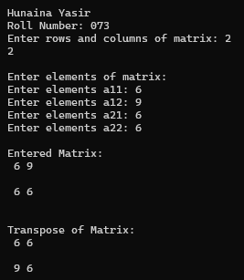

9.6 Write down the output of the following code.
- using namespace std;
- int mai#include <iostream>
- n(){
- int A[3][3];
- int B[3][3];
- int row, col, isEqual;
- for(row=0; row<3; row++){
- for(col=0; col<3; col++){
- cout<<"Enter matrix element of A["<<row<<"]["<<col<<"] ";
- cin>>A[row][col];
- }
- }
- for(row=0; row<3; row++){
- for(col=0; col<3; col++){
- cout<<"Enter matrix element of B["<<row<<"]["<<col<<"] ";
- cin>>B[row][col];
- }
- }
- isEqual = 1;
- for(row=0; row<3; row++){
- for(col=0; col<3; col++){
- if(A[row][col] != B[row][col]){
- isEqual = 0;
- break;
- }
- }
- }
- if(isEqual == 1){
- cout<<"\nMatrix A is equal to Matrix B";
- }
- else
- {
- cout<<"\nMatrix A is not equal to Matrix B";
- }
- return 0;
- }

Output:
Enter matrix element of A[0][0] 1
Enter matrix element of A[0][1] 2
Enter matrix element of A[0][2] 3
Enter matrix element of A[1][0] 4
Enter matrix element of A[1][1] 5
Enter matrix element of A[1][2] 6
Enter matrix element of A[2][0] 7
Enter matrix element of A[2][1] 8
Enter matrix element of A[2][2] 9
Enter matrix element of B[0][0] 10
Enter matrix element of B[0][1] 11
Enter matrix element of B[0][2] 12
Enter matrix element of B[1][0] 13
Enter matrix element of B[1][1] 14
Enter matrix element of B[1][2] 15
Enter matrix element of B[2][0] 16
Enter matrix element of B[2][1] 17
Enter matrix element of B[2][2] 18

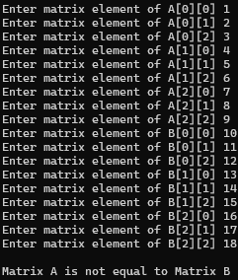
Matrix A is not equal to Matrix B

9.7 Write down the output of the following code.
- #include<iostream>
- using namespace std;
- int main(){
- int a[3][3], i, j, c[3],r[3], col, row;
- cout<<"Enter the number of rows and columns of the matrix:- \n";
- //Press the Return Button once.
- cin>>row>>col;
- cout<<"\nEnter the elements of the matrix:-\n";
- for ( i=0; i<row; i++)
- for ( j=0; j<col; j++)
- cin>>a[i][j];
- cout<<"\nGiven Matrix is as given below:- \n";
- for ( i=0; i<row; i++){
- cout<<"\n";
- for ( j=0; j<col; j++)
- cout<<a[i][j]<<"\t";
- }
- for ( i=0; i<row; i++){
- r[i]=0;
- for ( j=0; j<col; j++)
- r[i]+=a[i][j];
- }
- for ( j=0; j<col; j++){
- c[j]=0;
- for ( i=0; i<row; i++)
- c[j]+=a[i][j];
- }
- cout<<endl<<endl;
- for ( i=0; i<row; i++)
- cout<<"\nThe sum of row number "<<i+1<<" is "<<r[i];
- for ( j=0; j<col; j++)
- cout<<"\nThe sum of column number "<<j+1<<" is "<<c[j];
- return(0);
- }

Output:
Enter the number of rows and columns of the matrix:-
2
3

Enter the elements of the matrix:-
1
23
4
5
67
8

Given Matrix is as given below:-

1 23 4
5 67 8

The sum of row number 1 is 28
The sum of row number 2 is 80
The sum of column number 1 is 6
The sum of column number 2 is 90
The sum of column number 3 is 12
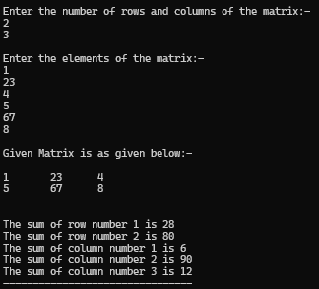

9.8 Write down the output of the following code.
- #include<iostream>
- using namespace std;
- int main(){
- int arr[20],even[20],odd[20],i,j=0,k=0,no;
- cout<<"How Size of Array: "; cin>>no;
- cout<<"Enter any "<<no<<" elements in Array: ";
- for(i=0; i<no;i++){
- cin>>arr[i];
- }
- for(i=0; i<no;i++){
- if(arr[i]%2==0){
- even[j]=arr[i];
- j++;
- }
- else
- {
- odd[k]=arr[i];
- k++;
- }
- }
- cout<<"\nEven Elements: ";
- for(i=0; i<j ;i++){
- cout<<even[i]<<" ";
- }
- cout<<"\nOdd Elements: ";
- for(i=0; i<k; i++)
- {
- cout<<odd[i]<<" ";
- }
- }

Output:
How Size of Array: 3
Enter any 3 elements in Array: 345
456
678

Even Elements: 456 678
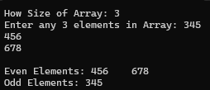
Odd Elements: 345

Exercises
9.1 Write a C++ program, which:
- Declares and initializes an integer array of 20 indexes.

- Finds the minimum, maximum, sum and average of the elements of this array using functions and,

- Prints these results on screen.

Your program should have the following interface.

The integer array is:
90, 87, 23, 3, 8, 34, 67, 75, 45, 90,
1, 2, 3, 4, 34, 44, 4, 78, 56, 12
The minimum value is 1 found at index [10]
The maximum value is 90 found at index [0][9]
The sum is 760.
The average is 38.

Source code:
#include <iostream>
using namespace std;

int findMin(int a[], int n, int &index) {
int min = a[0];
index = 0;
for (int i = 1; i < n; i++) {
if (a[i] < min) {
min = a[i];
index = i;
}
}
return min;
}

int findMax(int a[], int n, int &index1, int &index2) {
int max = a[0];
index1 = 0;
index2 = -1;
for (int i = 1; i < n; i++) {
if (a[i] > max) {
max = a[i];
index1 = i;
index2 = -1;
} else if (a[i] == max && index2 == -1) {
index2 = i;
}
}
return max;
}

int findSum(int a[], int n) {
int sum = 0;
for (int i = 0; i < n; i++) {
sum = sum + a[i];
}
return sum;
}

int main() {
cout << "Hunaina Yasir" << endl;
cout << "Roll Number: 073" << endl << endl;

int arr[20] = {90,87,23,3,8,34,67,75,45,90,1,2,3,4,34,44,4,78,56,12};

cout << "The integer array is:" << endl;
for (int i = 0; i < 20; i++) {
cout << arr[i];
if (i != 19) cout << ", ";
}
cout << endl << endl;

int minIndex;
int maxIndex1, maxIndex2;

int min = findMin(arr, 20, minIndex);
int max = findMax(arr, 20, maxIndex1, maxIndex2);
int sum = findSum(arr, 20);
int avg = sum / 20;

cout << "The minimum value is " << min << " found at index [" << minIndex << "]" << endl;
if (maxIndex2 == -1)
cout << "The maximum value is " << max << " found at index [" << maxIndex1 << "]" << endl;
else
cout << "The maximum value is " << max << " found at index [" << maxIndex1 << "][" << maxIndex2 << "]" << endl;

cout << "The sum is " << sum << "." << endl;
cout << "The average is " << avg << "." << endl;

return 0;
}

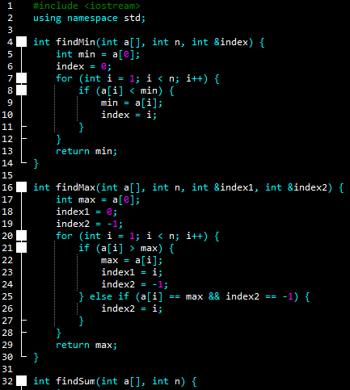

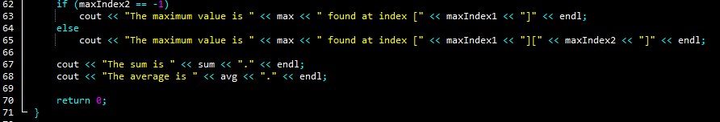
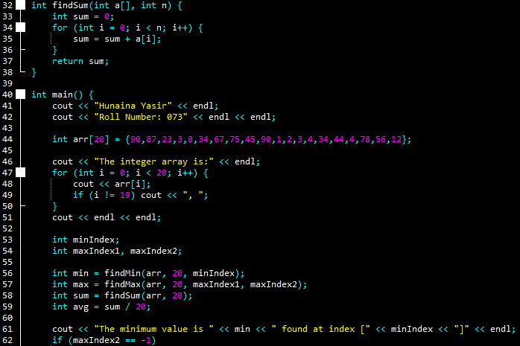

OUTPUT:
Hunaina Yasir
Roll Number: 073

The integer array is:
90, 87, 23, 3, 8, 34, 67, 75, 45, 90, 1, 2, 3, 4, 34, 44, 4, 78, 56, 12

The minimum value is 1 found at index [10]
The maximum value is 90 found at index [0][9]
The sum is 760.
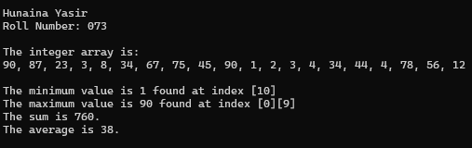
The average is 38.

9.2: Take input from the user to show a 3 x 3 array. Then take input from the user and search for that element in the array if element found in array, then show its index otherwise show the message “Element not found”.
Source code:
#include <iostream>
using namespace std;

int main() {
cout << "Hunaina Yasir" << endl;
cout << "Roll Number: 073" << endl << endl;

int arr[3][3];
int value;
bool found = false;

cout << "Enter elements of 3 x 3 array:" << endl;
for (int i = 0; i < 3; i++) {
for (int j = 0; j < 3; j++) {
cin >> arr[i][j];
}
}

cout << "Enter element to search: ";
cin >> value;

for (int i = 0; i < 3; i++) {
for (int j = 0; j < 3; j++) {
if (arr[i][j] == value) {
cout << "Element found at index [" << i << "][" << j << "]" << endl;
found = true;
}
}
}

if (!found) {
cout << "Element not found" << endl;
}

return 0;
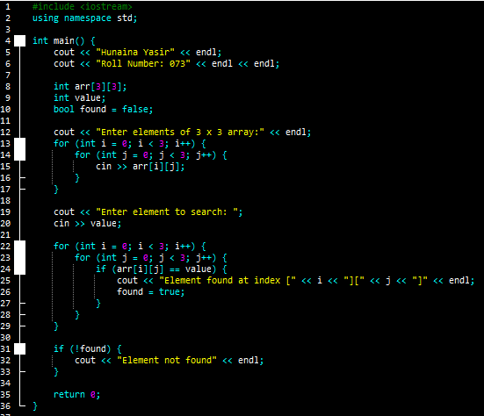
}

Output:
Hunaina Yasir
Roll Number: 073

Enter elements of 3 x 3 array:
2
3
4
6
7
8
9
0
9
Enter element to search: 5
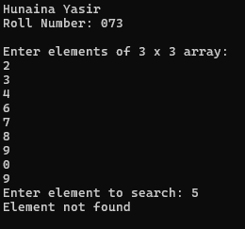
Element not found

9.3: (Traversing through Two-Dimensional Arrays)
Write C++ program such that the program searches through the array to find maximum and minimum values and displays them with their respective location numbers. Your program should have the following interface. You can use the same array you declared in Task 9.3.
Minimum Value is: 0
Found at location [3][5]
Found at location [4][0]
Found at location [9][8]
3 instances were found.
Maximum Value is: 9
Found at location [0][1]
Found at location [4][2]
2 instances were found.
The 10 x 10 array is:
8964657812
4631128745
6783423231
2321406784
0194765323
2121343786
6781213241
5121113476
7876443123
4321478301

Source code:
#include <iostream>
#include <cstdlib>
using namespace std;

int main() {
cout << "Hunaina Yasir" << endl;
cout << "Roll Number: 073" << endl << endl;

int arr[10][10];
int min, max;
int minCount = 0, maxCount = 0;

for (int i = 0; i < 10; i++) {
for (int j = 0; j < 10; j++) {
arr[i][j] = rand() % 10;
}
}

min = arr[0][0];
max = arr[0][0];

for (int i = 0; i < 10; i++) {
for (int j = 0; j < 10; j++) {
if (arr[i][j] < min)
min = arr[i][j];
if (arr[i][j] > max)
max = arr[i][j];
}
}

cout << "Minimum Value is: " << min << endl;
for (int i = 0; i < 10; i++) {
for (int j = 0; j < 10; j++) {
if (arr[i][j] == min) {
cout << "Found at location [" << i << "][" << j << "]" << endl;
minCount++;
}
}
}
cout << minCount << " instances were found." << endl;

cout << "Maximum Value is: " << max << endl;
for (int i = 0; i < 10; i++) {
for (int j = 0; j < 10; j++) {
if (arr[i][j] == max) {
cout << "Found at location [" << i << "][" << j << "]" << endl;
maxCount++;
}
}
}
cout << maxCount << " instances were found." << endl;

cout << "The 10 x 10 array is:" << endl;
for (int i = 0; i < 10; i++) {
for (int j = 0; j < 10; j++) {
cout << arr[i][j];
}
cout << endl;
}

return 0;
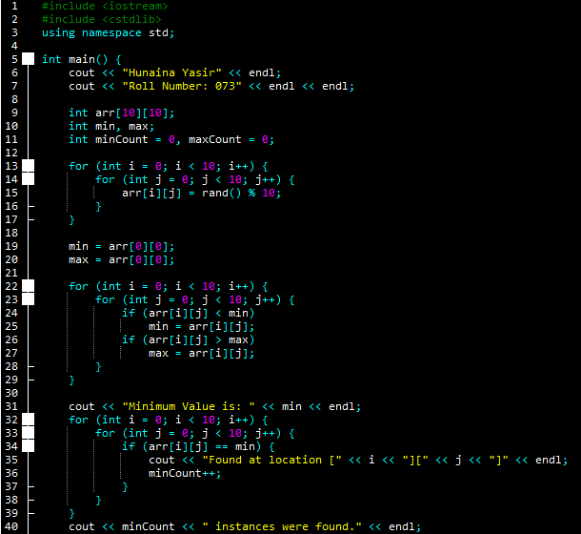
}

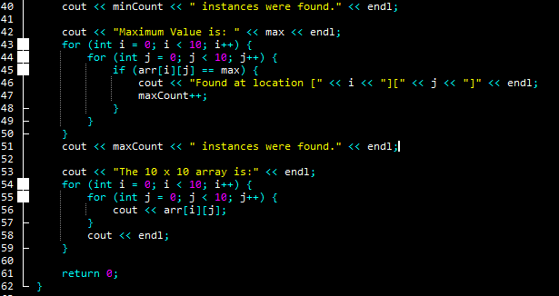
Output:
Hunaina Yasir
Roll Number: 073

Minimum Value is: 0
Found at location [0][3]
Found at location [6][2]
Found at location [6][6]
Found at location [7][2]
Found at location [7][4]
Found at location [7][5]
Found at location [8][5]
7 instances were found.
Maximum Value is: 9
Found at location [0][4]
Found at location [3][4]
Found at location [3][7]
Found at location [5][5]
Found at location [5][8]
Found at location [7][3]
Found at location [8][0]
Found at location [9][1]
Found at location [9][8]
9 instances were found.
The 10 x 10 array is:
1740948824
5517115276
1423221685
7618927954
3123341138
7427793198
6502860248
6509006138
9344606618
4963788291

